Important:
A domain purchased from Azure App Service or GoDaddy can be fully used with a public Azure VM by creating an A record pointing to the VM’s public IP. Nothing else special is required.
1. Domains Purchased via Azure App Service
When you buy a domain directly in App Service:
- Azure automatically creates and manages a public DNS zone for that domain behind the scenes.
- You do NOT need to manually create an A/CNAME record in Azure DNS for the domain itself to point to an App Service — App Service can handle the binding automatically.
- The name servers are already registered with the domain because Azure manages the domain registration.
2. Using the Domain for an Azure VM (or any other public service)
If you want to use that same domain for a public VM instead of the App Service:
- DNS management matters:
  - Domains purchased via App Service are managed in Azure’s domain management.
  - To point the domain to a VM, you need to create an A record pointing to the VM’s public IP.
- No need to update registrar name servers:
  - Azure already controls the NS records because it is the registrar.
  - You just add the appropriate DNS record in the Azure portal for the domain.

# Add Custom Domain to Azure VM or resource
Applies to: ✔️ Linux VMs ✔️ Windows VMs ✔️ Flexible scale sets
In Azure there are multiple ways to connect a custom domain to your VM or resource. For any resource with a public IP (Virtual Machine, Load Balancer, Application Gateway) the most straight-forward way is to create an A record set in your corresponding domain registrar.
Prerequisites
- You need a VM with a web server running.
- The VM must be accessible to the web (open port 80, or 443). For a more secure deployment place your VM behind a load balancer or Application Gateway first
- Have an existing domain and access to DNS settings. For more information, see Buy a custom domain for Azure App Service.
Note: We can use any external domain for the VM.

Add custom domain to VM public IP address: When you create a virtual machine in the Azure portal, a public IP resource for the virtual machine is automatically created. Your public IP address is shown in VM overview page.
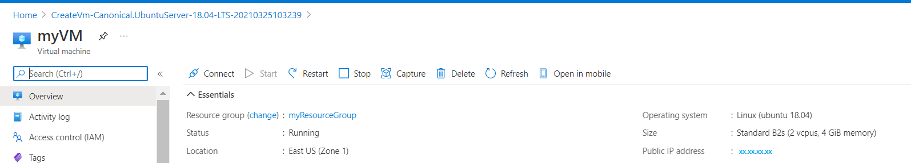
If you select the IP address you can see more information on it. Check to make sure your IP Assignment is set to Static. A static IP address will not change if the VM or resource reboots or shuts down.
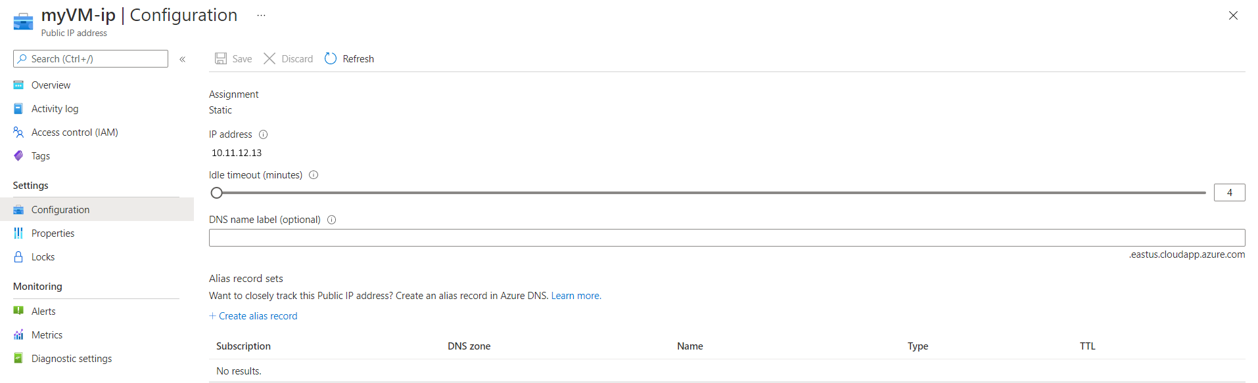
If your IP Address is not static, you will need to create an FQDN.
- Select your VM in the portal.
- In the left menu, select Properties
- Under Public IP address\DNS name label, select your IP address. The Configuration page will open.
- Under DNS name label, enter the prefix you want to use.
- Select Save at the top of the page.
- Select Overview in the left menu to return to the VM overview blade.
- Verify that the DNS name appears correctly.
Open a browser and enter your IP address or FQDN and verify that it shows the web content running on your VM.
After verifying your static IP or FQDN, go to your domain provider and navigate to DNS settings. Add an A record pointing to your Public IP Address or FQDN. For example, the procedure for the GoDaddy domain registrar is as follows:
- Sign in and select the custom domain you want to use.
- In the Domains section, select Manage All, then select DNS | Manage Zones.
- For Domain Name, enter your custom domain, then select Search.
- From the DNS Management page, select Add, then select A in the Type list.
- Complete the fields of the A entry:
  - Type: Leave A selected.
  - Host: Enter @
  - Points to: Enter the Public IP Address or FQDN of your VM.
  - TTL: Leave one hour selected.
- Select Save.
The A record entry is added to the DNS records table.
After the record is created it usually takes about an hour for DNS propagate, but it can sometimes take up to 48 hours.

